UNLOCKING INSIGHTS INTO THE GLOBAL AIR TRANSPORTATION NETWORK WITH TABLEAU

# 1. Introduction:

# 1.1. Overview:

This Global Air Transportation Network dataset is a comprehensive collection of information on airports, airlines and their routes. It contains information such as names, cities, countries, codes (IATA and ICAO) longitudes, latitudes and altitudes of airports across the world with detailed time zone and daylight saving time data. Additionally, this includes information about airlines including their IDs, name aliases, IATA and ICAO codes, call signs country of origin and active/inactive status. Similarly, it also covers route details such as airline sources to destination airports along with essential details like codeshare stakeholder if any stops required during this journey along with the type of aircraft being used for that particular journey.

## 1.2. Purpose:

To give you a comprehensive detail into air transportation networks from around the globe.

## 2. Problem statement and Design thinking:

Comprehensive detail into air transportation networks from around the globe.

## 2.1. Empathy map:

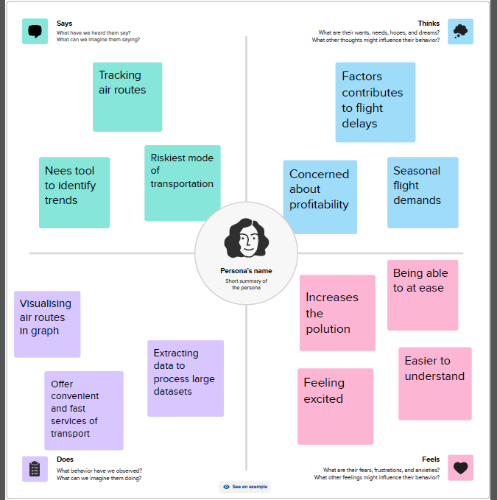

UNLOCKING INSIGHTS INTO THE GLOBAL AIR TRANSPORTATION NETWORK WITH TABLEAU

## Ideation and Brainstorming Map:

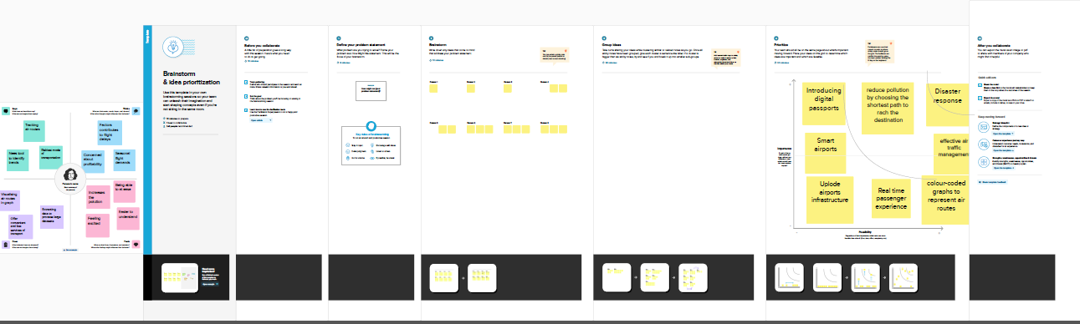

## 3. Result:

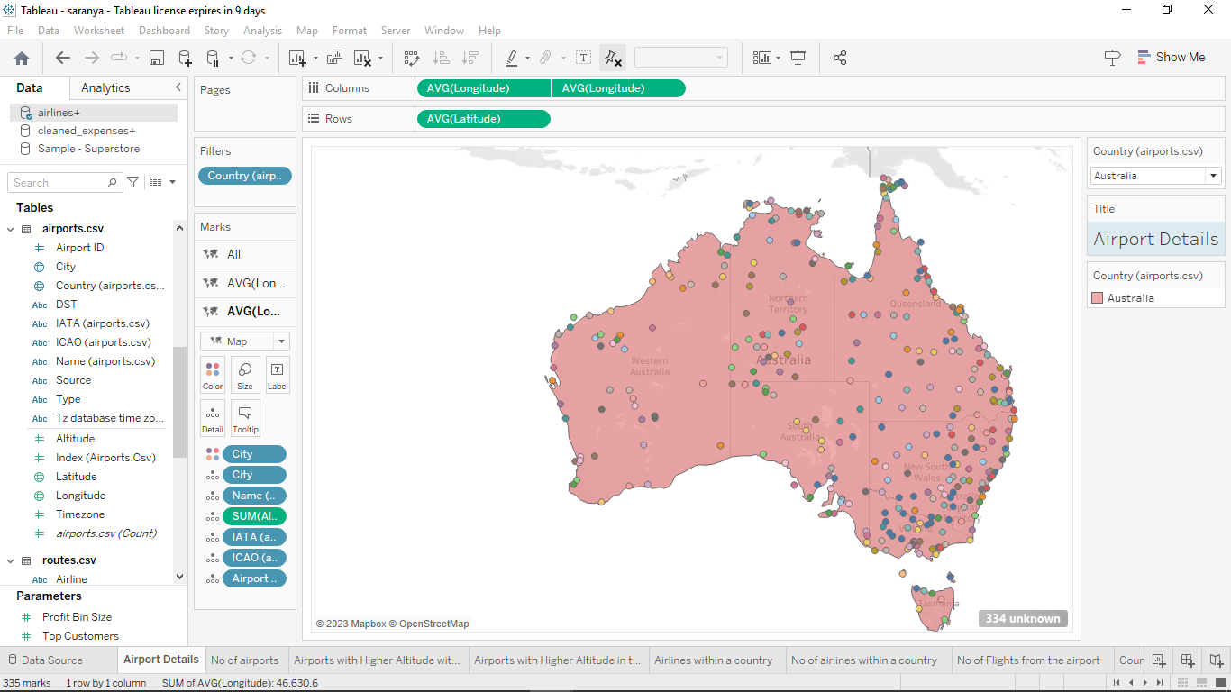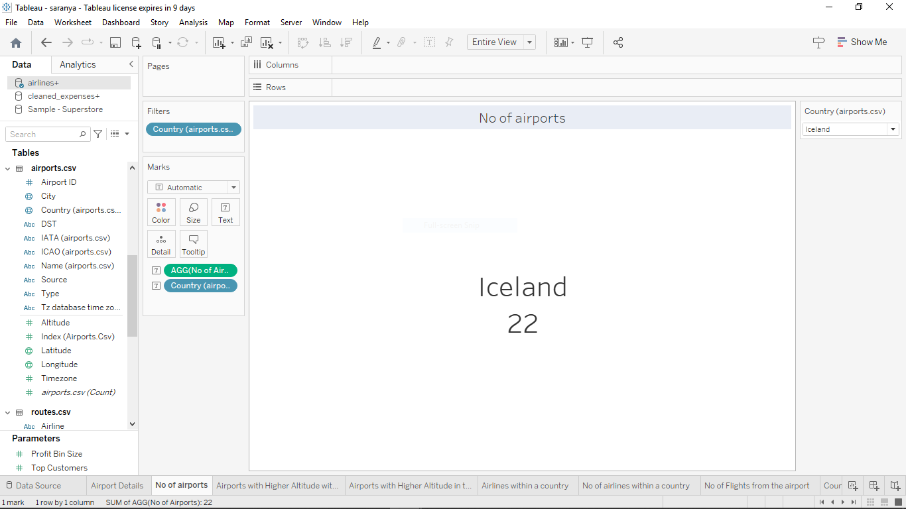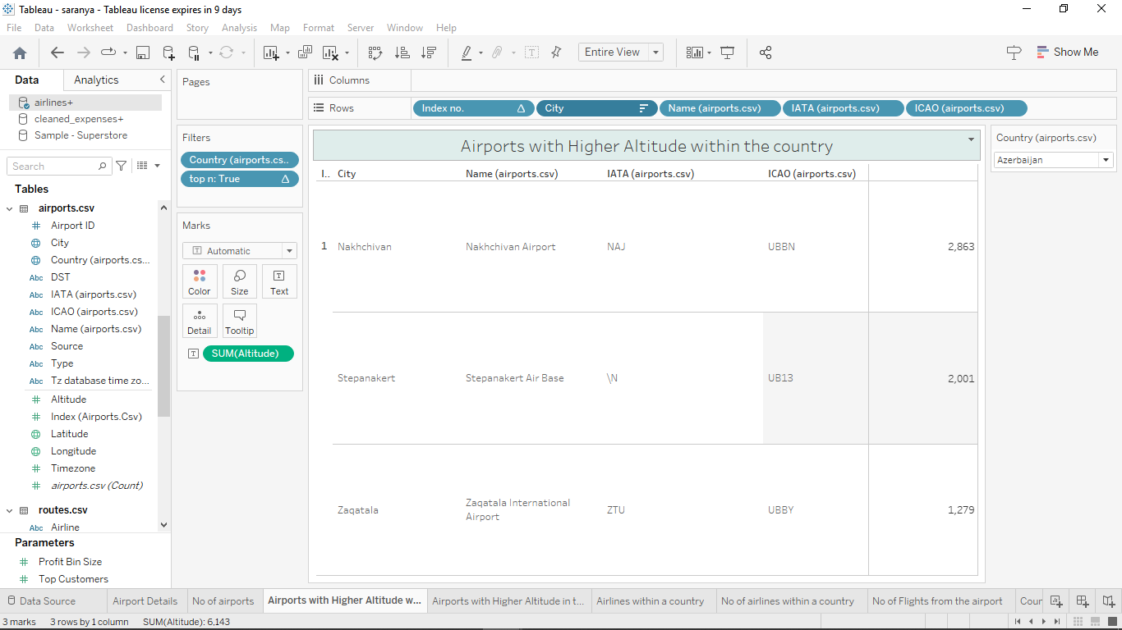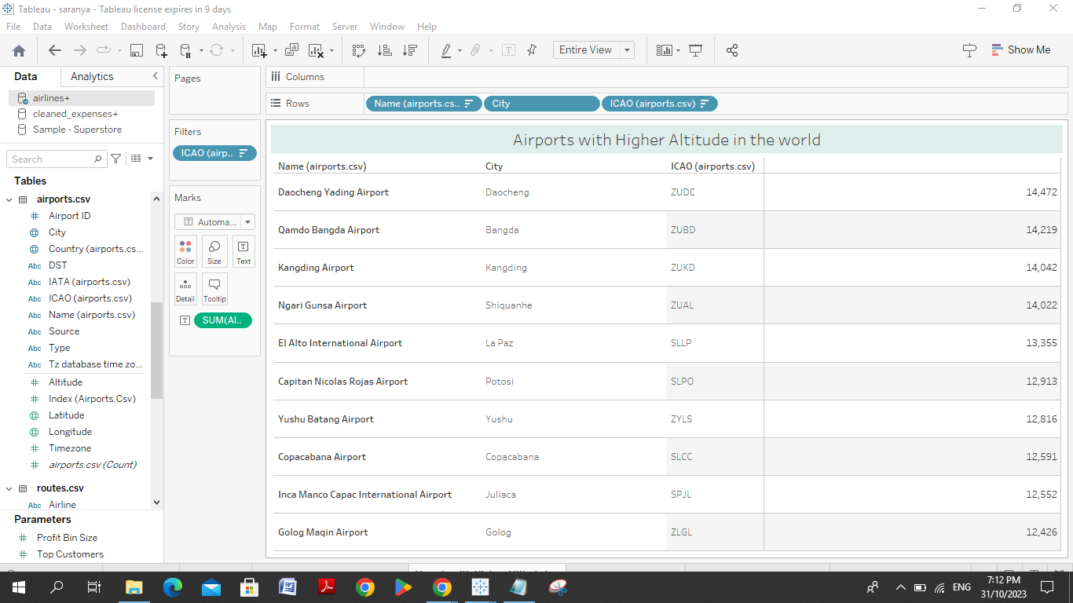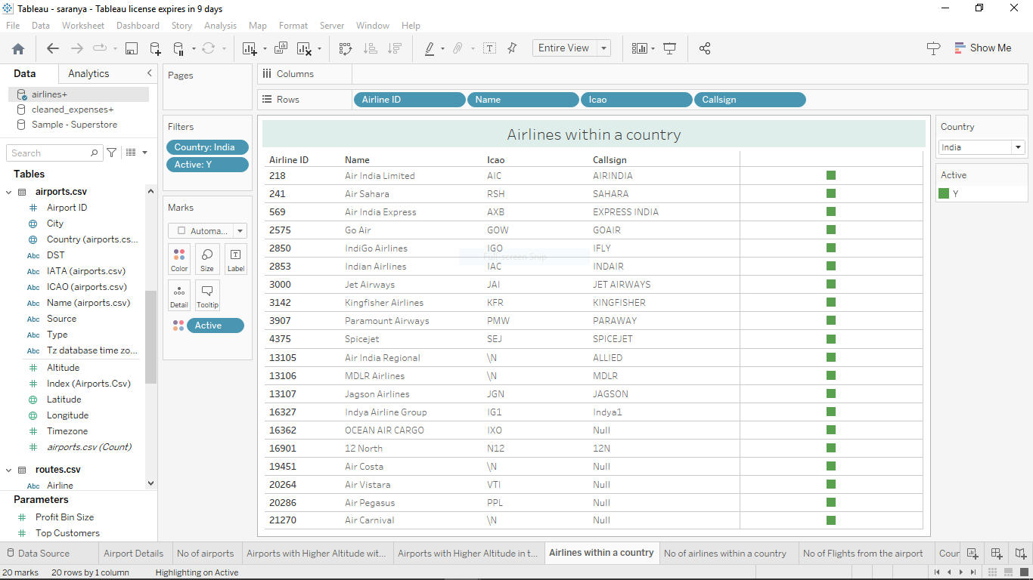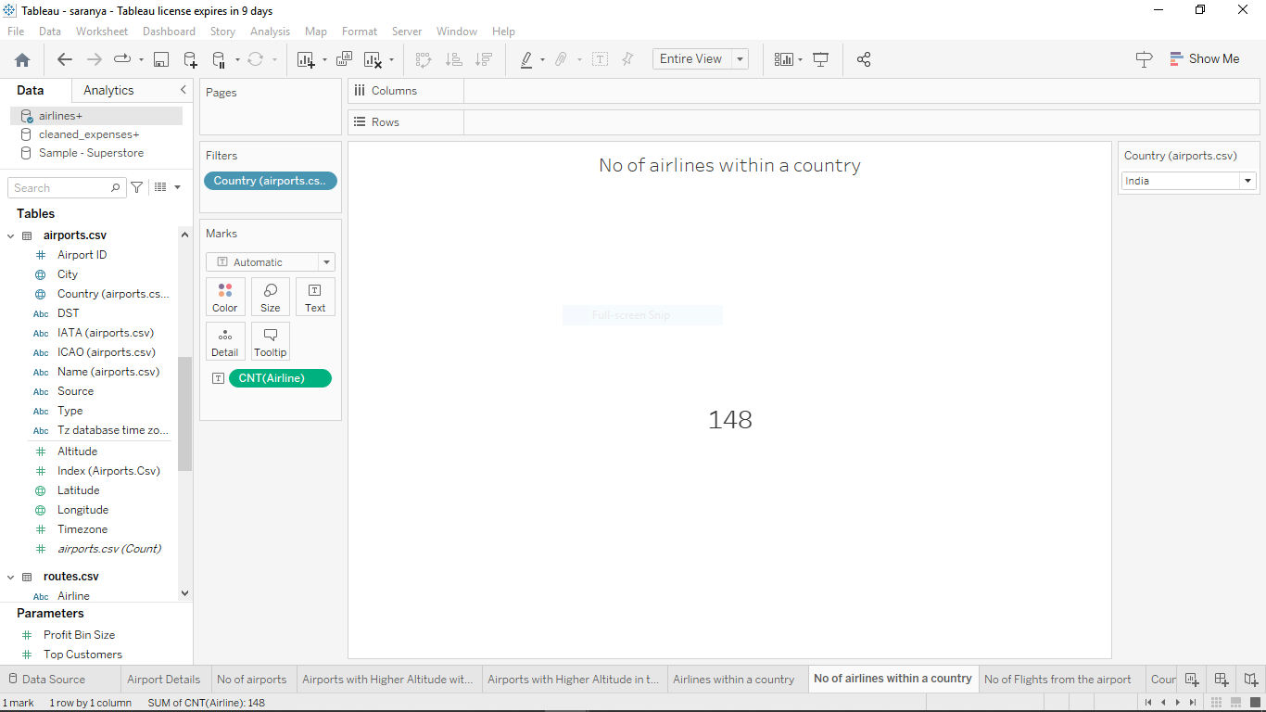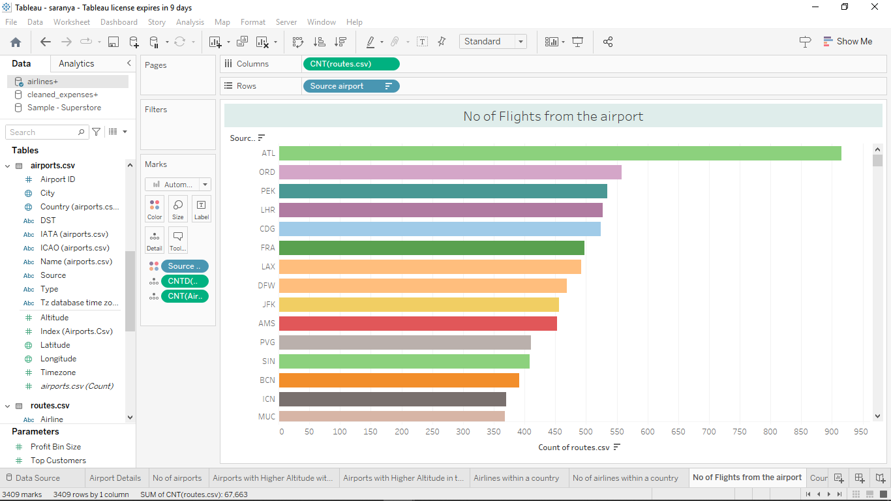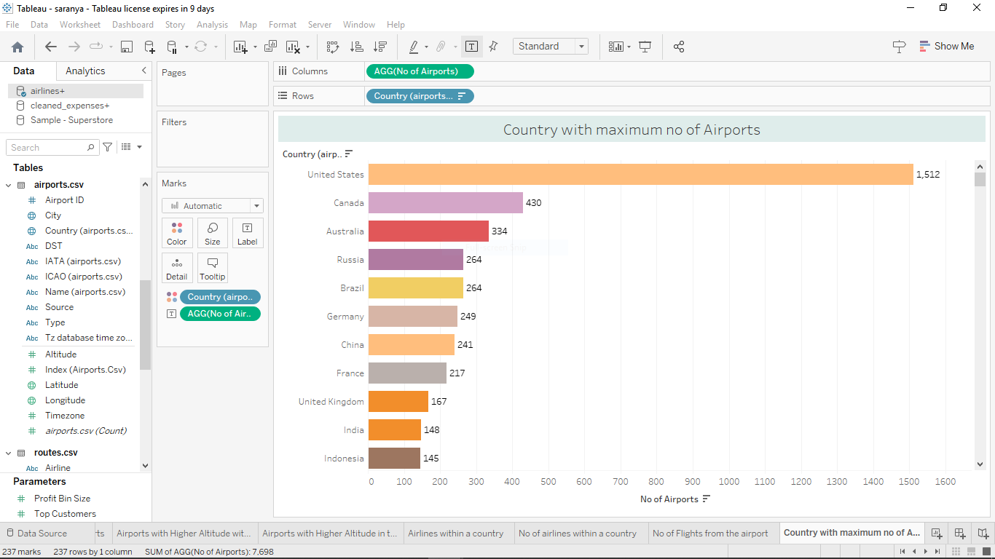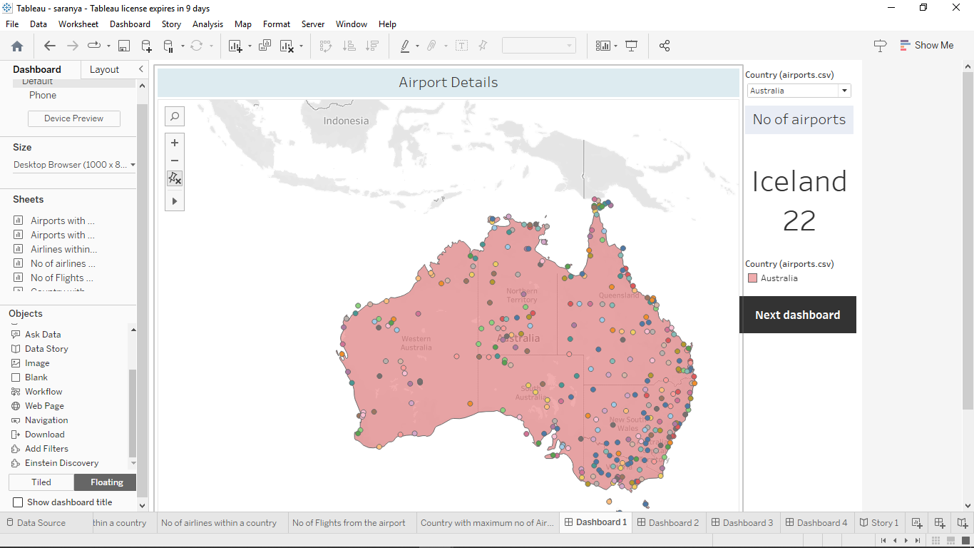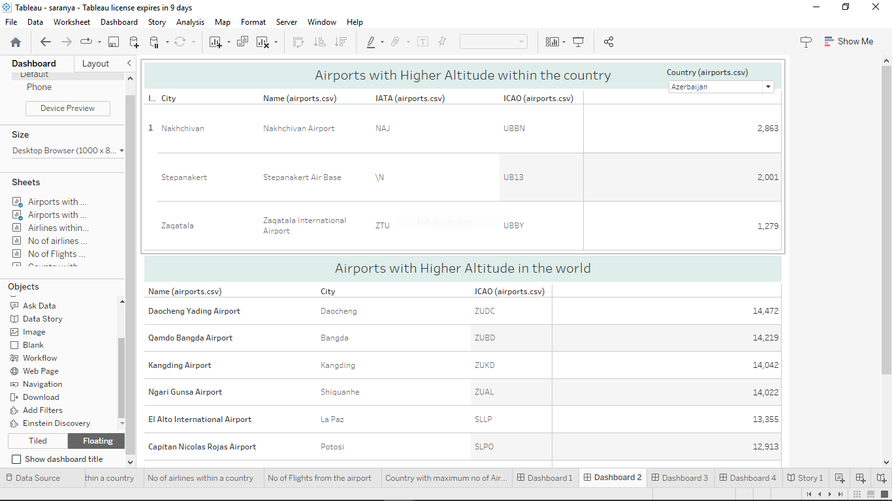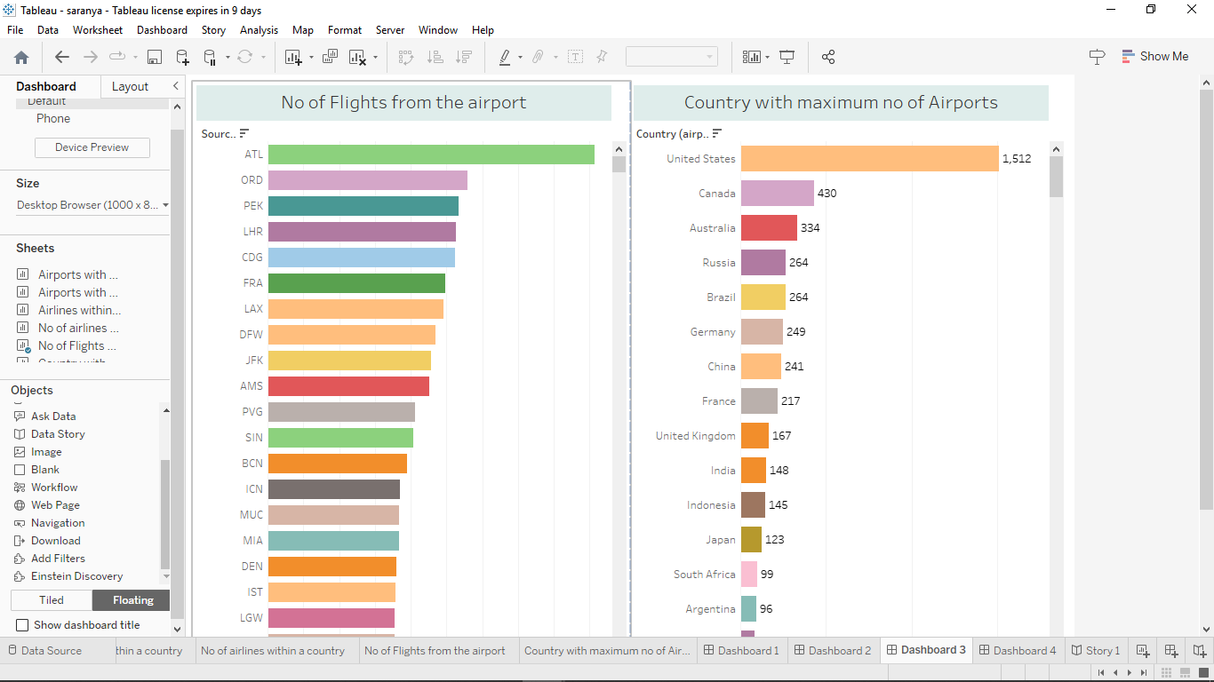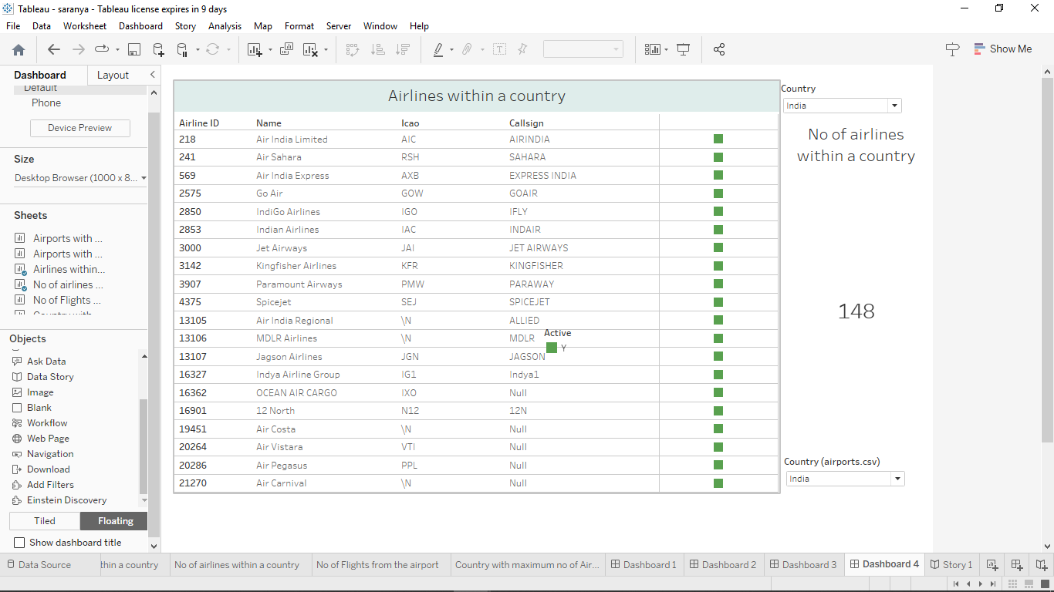

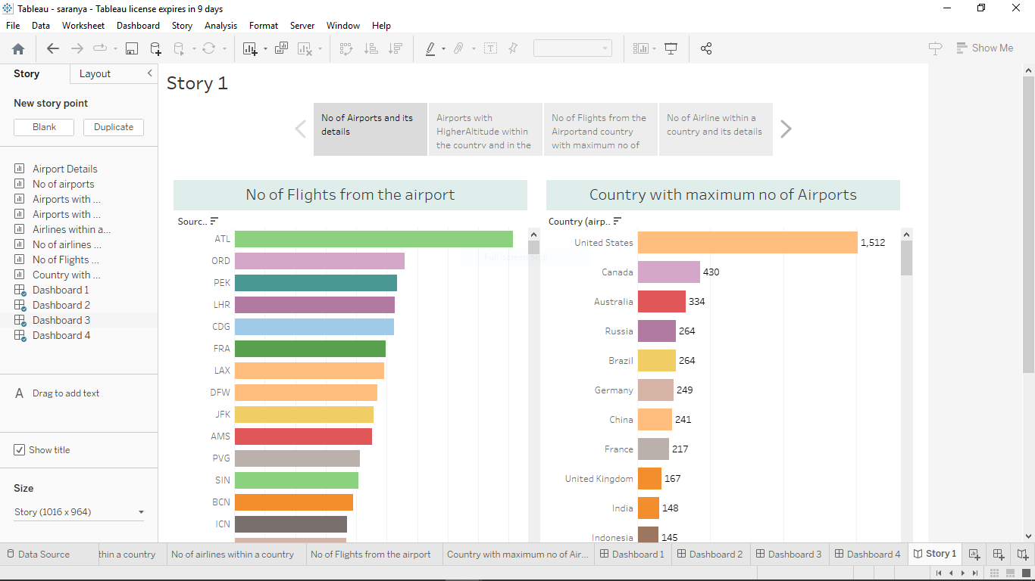

## 4. Advantages and Disadvantages:

## Advantages:

* We can analyze data easily

* Anyone can understand it

* Proper visualization

**\* Help and aviation**

## Disadvantages:

* Requires a lot of knowledge

* Hard to handle

## 5. Application:

The application of this network is providing data to people who require information about aviation for traveling, doing business, rescuing missions and so on.

## 6. Conclusion:

So, in this project, we have seen about details of airports, no. of airports within the country, airlines within the country, no. of airlines, its active status, airports at higher altitude within the country and in the world, country with maximum number of airports and no. of flights from airport.

## 7. Future scope:

It can be used in various sectors like choosing shortest path distance to reach the destination, for

quick disaster response, effective air traffic management and so on.